1.Identification and solving of simple real life or scientific or technical problems, and
developing flow charts for the same.

(Electricity Billing, Retail shop billing, Sin series, weight of a motorbike, Weight of a steel bar, compute Electrical Current in Three Phase AC Circuit)

Date: 1.A. Electricity Billing
Aim
To write a python program for the Electricity Billing.

Algorithm
Step 1: Start the program
Step 2: Read the input variable “unit”
Step 3: Process the following
If the unit is less than or equal to 100 units, calculate usage=unit*5
If the unit is between 100 to 200 units, calculate usage=(100*5)+((unit-100)*7)
If the unit is between 200 to 300 units, calculate usage=(100*5)+(100*7)+((unit- 200)*10)
If the unit is above 300 units, calculate usage=(100*5)+(100*7)+(100*!0)+((unit- 300)*15) For further, no additional charge will be calculated.
Step 4: Display the amount usage to the user.
Step 5: Stop the program

Flowchart
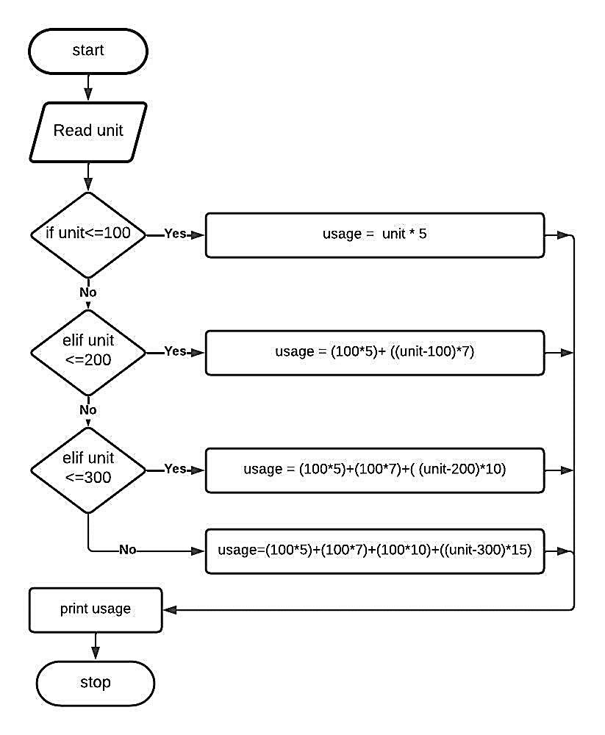
Program unit = int(input("Please enter Number of Unit you Consumed : "))
if(unit <= 100): usage = unit * 5 elif(unit <= 200):
usage=(100*5)+((unit-100)*7) elif(unit <= 300): usage=(100*5)+(100*7)+((unit-200)*10) else: usage=(100*5)+(100*7)+(100*10)+((unit-300)*15)
print("Electricity Bill = %.2f" %usage) print("Note:
No additional charge will be calculated")

Output
Please enter Number of Unit you consumed: 650
Electricity Bill = 7450.00
Note: No additional charge will be calculated

Particulars | Marks Allotted | Marks Obtained
Performance | 50
Viva-voce | 10
Record | 15
Total | 75

Result
Thus the Electricity Billing program has been executed and verified successfully.

Date: 1.B.Retail Shop Billing
Aim
To write a python program for the Retail Shop Billing.

Algorithm
Step 1: Start the program
Step 2: Initialize the values of the items
Step 3: Read the input like the name of item and quantity. Step 4: Process the following amount=(item_name*quantity)+amount Step 5:
Repeat the step4 until the item is 0.
Step 6: Display the value of amount.
Step 7: Stop the program.

Flowchart
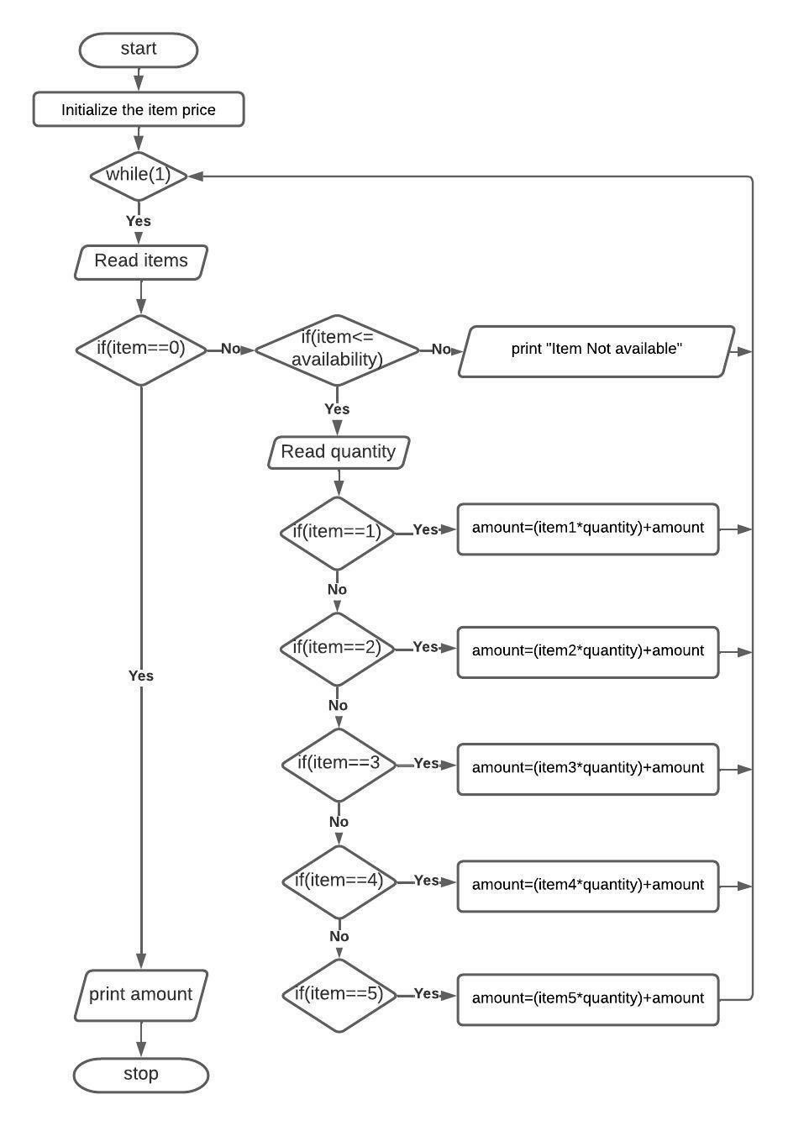
Program print("Welcome to Varnika Retail Shopping") print("List of items in our market") soap=60; powder=120; tooth_brush=40; paste=80; perfume=250 amount=0 print("1.Soap\n2.Powder\n3.Tooth Brush\n4.Tooth Paste\n5.Perfume") print("To Stop the shopping type number 0") while(1):
item=int(input("Enter the item number:")) if(item==0): break else: if(item<=5):
quantity=int(input("Enter the quantity:"))
if(item==1): amount=(soap*quantity)+amount elif(item==2): amount=(powder*quantity)+amount elif(item==3):
amount=(tooth_brush*quantity)+amount elif(item==4):
amount=(paste*quantity)+amount elif(item==5):
amount=(perfume*quantity)+amount
else:
print("Item Not available") print("Total amount need to pay is:",amount) print("Happy for your visit")

Output
Welcome to Varnika Retail Shopping
List of items in our market
1.Soap
2.Powder
3.Tooth Brush
4.Tooth Paste
5.Perfume
To Stop the shopping type number 0
Enter the item number:1
Enter the quantity:5
Enter the item number:2
Enter the quantity:4
Enter the item number:0
Total amount need to pay is: 780
Happy for your visit

Particulars | Marks Allotted | Marks Obtained
Performance | 50
Viva-voce | 10
Record | 15
Total | 75

Result
Thus the Retail Shopping Billing program has been executed and verified successfully.

Date: 1.C. Sin Series
Aim
To write a python program for sin series.

Algorithm
Step 1: Start the program.
Step 2: Read the input like the value of x in radians and n where n is a number up to which we want to print the sum of series.
Step 3: For first term, x=x*3.14159/180 t=x; sum=x
Step 4: For next term, t=(t*(-
1)*x*x)/(2*i*(2*i+1)) sum=sum+t;
# The formula for the 'sin x' is represented as
# sin x= x-x3/3!+x5/5!-x7/7!+x9/9! (where x is in radians)
Step 5: Repeat the step4 'n' times to get the sum of first 'n' terms of the series.
Step 6: Display the value of sum.
Step 7: Stop the program.

Flowchart
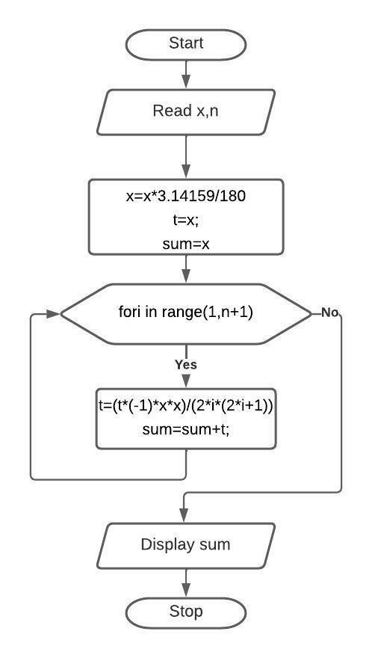

Program:
x=float(input("Enter the value for x : "))
a=x n=int(input("Enter the value for n :
")) x=x*3.14159/180 t=x; sum=x for i in
range(1,n+1):
t=(t*(-1)*x*x)/(2*i*(2*i+1)) sum=sum+t; print("The value of Sin(",a,")=",round(sum,2)) Output
Enter the value for x : 30
Enter the value for n : 5
The value of Sin( 30.0 )= 0.5

Particulars | Marks Allotted | Marks Obtained
Performance | 50
Viva-voce | 10
Record | 15
Total | 75

Result
Thus the sine series program has been executed and verified successfully.

Date: 1.D. Weight of a Motorbike
Aim
To write a python program to find the weight of a motorbike.

Algorithm
Step 1: Start the program
Step 2: Initialize values to the parts of the motorbike in weights(Chassis, Engine, Transmissions,
Wheels, Tyres, Body panels, Mud guards, Seat, Lights)
Step 3: Process the following weight = weight+sum_motorbike[i]
Step 4: Repeat the step 3 'n' times to get the sum of weight of the vehicle
Step 5: Display the Parts and Weights of the motor bike
Step 6: Display “Weight of theMotorbike” Step 7: Stop the program.

Flowchart
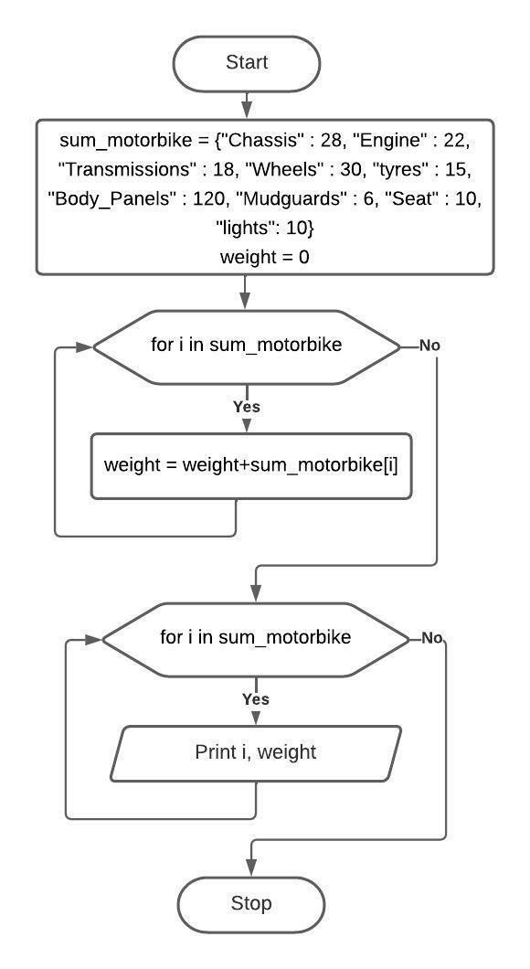
Program:
sum_motorbike = {"Chassis" : 28, "Engine" : 22, "Transmissions" : 18, "Wheels" : 30, "tyres" : 15,
"Body_Panels" : 120, "Mudguards" : 6, "Seat" : 10, "lights": 10}
weight = 0 for i in sum_motorbike:
weight = weight+sum_motorbike[i] print("Parts and weights of the Motorbike")
for i in sum_motorbike.items():
print(i)
print("\nWeight of the Motorbike is:",weight)

Output
Parts and weights of the Motorbike
('Chassis', 28)
('Engine', 22)
('Transmissions', 18)
('Wheels', 30)
('tyres', 15)
('Body_Panels', 120)
('Mudguards', 6)
('Seat', 10)
('lights', 10)
Weight of a Motorbike is: 259

Particulars | Marks Allotted | Marks Obtained
Performance | 50
Viva-voce | 10
Record | 15
Total | 75

Result
Thus the weight of the motorbike program has been executed and verified successfully.

Date: 1.E. Weight of a steel bar
Aim
To write a python program to find the weight of a steel bar.

Algorithm

Weight of steel bar = (d2 /162)*length (Where d-diameter value in mm and length value in m) Step 1: Start the program.
Step 2: Read the values of the variable d and length. Step 4:
Process the following weight=(d2 /162kg/m)*length Step 5:
Display the value of weight.
Step 6: Stop the program.

Flowchart
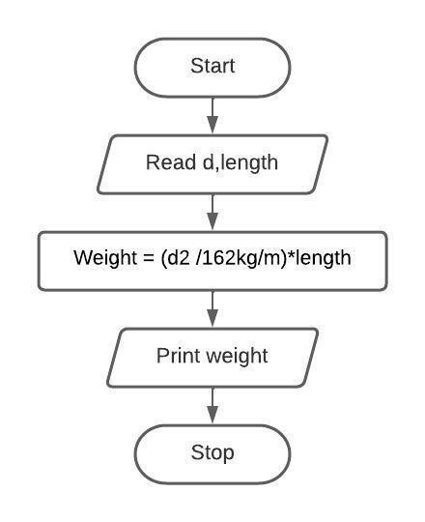

d=int(input("Enter the diameter of the steel bar in milli meter: " ))
length=int(input("Enter the length of the steel bar in meter: " )) weight=((d**2)/162)*length print("Weight of steel bar in kg per meter :", round(weight,2))

Output
Enter the diameter of the steel bar in milli meter: 6
Enter the length of the steel bar in meter: 3
Weight of steel bar in kg per meter : 0.67

Particulars | Marks Allotted | Marks Obtained
Performance | 50
Viva-voce | 10
Record | 15
Total | 75

Result
Thus the weight of the steel bar program has been executed and verified successfully.
Date: 1.F. Compute Electrical Current in Three Phase AC Circuit

Aim
To write a python program to compute the Electrical Current in Three Phase AC Circuit.
Algorithm

Step 1: Start the program
Step 2: Import math header file for finding the square root of 3 Step 3: Read the values of pf, I and V.
Step 4: Process the following:
Perform a three phase power calculation using the following formula: P=√3 * pf * I * V Where pf - power factor, I - current, V - voltage and P – power
Step 5: Display “The result is P”. Step 6: Stop the program.

Flowchart
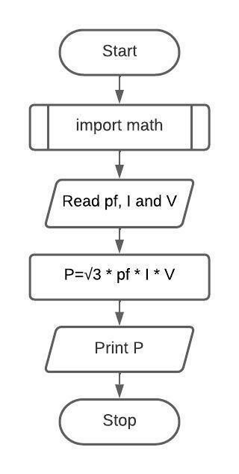

Program
import math
pf=float(input("Enter the Power factor pf (lagging): " ))
I=float(input("Enter the Current I: " ))
V=float(input("Enter the Voltage V: " )) P=math.sqrt(3)*pf*I*V print("Electrical Current in Three Phase AC Circuit :", round(P,3))

Output
Enter the Power factor pf (lagging): 0.8
Enter the Current I: 1.7
Enter the Voltage V: 400
Electrical Current in Three Phase AC Circuit : 942.236

Particulars | Marks Allotted | Marks Obtained
Performance | 50
Viva-voce | 10
Record | 15
Total | 75

Result
Thus the Electrical Current in Three Phase AC Circuit program has been executed and verified successfully.

2.Python programming using simple statements and expressions

(Exchange the values of two variables, circulate the values of n variables, distance between two points).

Date: 2.A. Exchange the values of two variables

Aim
To write a python program to exchange the values of two variables.

Algorithm

Step 1: Start the program
Step 2: Read the values of two variables
Step 3: Print the values of the two variables before swapping.
Step 4: Process the following
Swapping of two variables using tuple assignment operator.
a,b=b,a
Step 5: Display the values of the two variables after swapping.
Step 6: Stop the program.

Program
#with temporary variable print("Swapping two values") a=int(input("Enter the value of A: ")) b=int(input("Enter the value of B: ")) print("Before Swapping\nA value is:",a,"B value is:",b) c=a
#with temporary variable a=b b=c print("After
Swapping\nA value is:",a,"B value is:",b)

#without temporary variable print("Swapping two values") a=int(input("Enter the value of A: ")) b=int(input("Enter the value of B: ")) print("Before Swapping\nA value is:",a,"B value is:",b) a=a+b
#without temporary variable b=a-b a=a-b print("After Swapping\nA value is:",a,"B value is:",b) #Tuple assignment print("Swapping two values") a=int(input("Enter the value of A: ")) b=int(input("Enter the value of B: ")) print("Before Swapping\nA value is:",a,"B value is:",b) a,b=b,a #Tuple assignment print("After Swapping\nA value is:",a,"B value is:",b)

Output
Swapping two values
Enter the value of A: 65
Enter the value of B: 66
Before Swapping
A value is: 65 B value is: 66
After Swapping
A value is: 66 B value is: 65

Particulars | Marks Allotted | Marks Obtained
Performance | 50
Viva-voce | 10
Record | 15
Total | 75

Result
Thus the exchange the values of two variables program has been executed and verified successfully.
Date: 2.B. Circulate the values of n variables
Aim
To write a python program to circulate the values of n variables

Algorithm

Step 1: Start the program
Step 2: Read the values of two variables
Step 3: Display the values of the two variables before swapping.
Step 4: Process the following
Swapping of two variables using tuple assignment operator.
a,b=b,a
Step 5: Display the values of the two variables after swapping.
Step 6: Stop the program.

Program
print("Circulate the values of n variables") list1=[10,20,30,40,50] print("The given list is: ",list1) n=int(input("Enter how many circulations are required:
")) circular_list=list1[n:]+list1[:n] print("After",n,"circulation is: ",circular_list)

Output
Circulate the values of n variables
The given list is: [10, 20, 30, 40, 50]
Enter how many circulations are required: 3
After %f circulation is: [40, 50, 10, 20, 30]

Program from collections import deque lst=[1,2,3,4,5] d=deque(lst) print d
d.rotate(2) print d

Output deque([1, 2, 3, 4, 5]) deque([4, 5, 1, 2, 3])

Particulars | Marks Allotted | Marks Obtained
Performance | 50
Viva-voce | 10
Record | 15
Total | 75

Result
Thus circulate the values of n variables program has been executed and verified successfully.

Date: 2.C. Distance between two points
Aim
To write a python program to find the distance between two points

Algorithm

Step 1: Start the program
Step 2: Read the values of two points (x1,y1,x2,y2)
Step 3: Process the following
Result=math.sqrt(((x2-x1)**2)+((y2-y1)**2)) Step 4: Display the result of distance between two points.
Step 5: Stop the program.

Program
import math print("Enter the values to find the distance between two points") x1=int(input("Enter X1 value: ")) y1=int(input("Enter Y1 value: ")) x2=int(input("Enter X2 value: ")) y2=int(input("Enter Y2 value: "))
Result=math.sqrt(((x2-x1)**2)+((y2-y1)**2)) print("Distance between two points:",int(Result))

Output
Enter the values to find the distance between two points
Enter X1 value: 2
Enter Y1 value: 4
Enter X2 value: 4
Enter Y2 value: 8
Distance between two points: 4

Particulars | Marks Allotted | Marks Obtained
Performance | 50
Viva-voce | 10
Record | 15
Total | 75

Result
Thus the distance between two points program has been executed and verified successfully.

3.Scientific problems using Conditionals and Iterative loops

(Number series, Number Patterns, pyramid pattern)

Date: 3.A. Number Series
Aim
To write a python program for the Number Series

a. Fibonacci sequence: 0 1 1 2 3 5 8 13 21 34

Algorithm
Step 1: Start the program
Step 2: Read the number of terms n
Step 3: Initialize f1 = -1, f2 = 1
Step 4: Repeat the following until it reaches n
f3=f1+f2
Display f3
Do the tuple assignment f1,f2=f2,f3 Step 5: Stop the program.

Program print("Program for Number Series : Fibanacci Sequence") n=int(input("How many terms? ")) f1=-1 f2=1 for i in range(n): f3=f1+f2 print(f3,end=" ") f1,f2=f2,f3

Output
Program for Number Series : Fibanacci Sequence
How many terms? 10
Fibonacci sequence: 0 1 1 2 3 5 8 13 21 34

b. Number Series: 1²+2²+…+n²

Algorithm
Step 1: Start the program
Step 2: Read the number of terms n
Step 3: Initialize sum=0
Step 4: Repeat the following until it reaches n
Sum = sum + i**2
Step 5: Display sum Step 6: Stop the program.
Program
print("Program for Number Series") n=int(input("How many terms? ")) sum=0 for i in range(1,n+1): sum+=i**2 print("The sum of series = ",sum)

Output
Program for Number Series :
How many terms? 5
The sum of series = 55

Particulars | Marks Allotted | Marks Obtained
Performance | 50
Viva-voce | 10
Record | 15
Total | 75

Result
Thus the number series program has been executed and verified successfully.

Date: 3.B. Number Patterns
Aim
To write a python program for the Number Patterns
- Number Pattern_Type 1

Algorithm
Step 1: Start the program
Step 2: Read the number of rows
Step 3: Outer loop i is used for number of rows
Step 4: Inner loop j is used to print the value of i in pattern Step 5: Line after each row to display the pattern correctly Step 5: Stop the program.

Program
print("Program for Number Pattern") rows=int(input("Enter the number of rows: ")) for i in range(1,rows+1):
for j in range(0,i):
print(i,end=" ")
print(" ")

Output
Program for Number Pattern
Enter the number of rows: 5
1
- 2
- 3 3
- 4 4 4
- 5 5 5 5

- Number Pattern_Type 2
Algorithm
Step 1: Start the program
Step 2: Read the number of rows
Step 3: Outer loop i is used for number of rows
Step 4: Inner loop j is used to print the value of j in pattern Step 5: Line after each row to display the pattern correctly Step 6: Stop the program.

Program
b. Number Pattern print("Program for Number Pattern") rows=int(input("Enter the number of rows: ")) for i in range(1,rows+1): for j in range(1,i+1): print(j,end=" ") print(" ")

Output
Program for Number Pattern
Enter the number of rows: 5
1
1 2
1 2 3
1 2 3 4
1 2 3 4 5
Particulars | Marks Allotted | Marks Obtained
Performance | 50
Viva-voce | 10
Record | 15
Total | 75

Result
Thus the number patterns programs have been executed and verified successfully.

Date: 3.C. Pyramid Patterns
Aim
To write a python program for the Pyramid Patterns

Algorithm
Step 1: Start the program
Step 2: Read the number of rows
Step 3: Outer loop i is used for number of rows
Step 4: Inner loop space is used to print empty space in pattern Step 5: Inner loop j is used to display the * in pyramid pattern Step 6: Stop the program.

Program
Pyramid pattern rows = int(input("Enter number of rows: ")) for i in range(1, rows+1): for space in range(1, (rowsi)+1):
print(end=" ") for j in range(0,2*i-1): print("* ", end="")
print()

Output
Program for Pyramid Pattern
Enter the number of rows: 4
*
- * *
- * * * *
- * * * * * *

Particulars | Marks Allotted | Marks Obtained
Performance | 50
Viva-voce | 10
Record | 15
Total | 75

Result
Thus the pyramid pattern program has been executed and verified successfully.

4. Implementing real-time/technical applications using Lists, Tuples

(Items present in a library/Components of a car/ Materials required for construction of a building –
operations of list & tuples)

Date: 4.A.Items present in a library
Aim
To write a python program to find the items present in a library using lists.

Algorithm
Step 1: Start the program
Step 2: Initialize the Library list with the following items "Books","e-Books”, "Journals","Audiobooks","Manuscripts","Maps","Prints","Periodicals",
"Newspapers"
Step 3: Loop is used to display the items from the Library list
Step 4: Remove an item “Prints” from the Library list
Step 5: Display all items from the Library list
Step 6: Remove 4th index item from the Library list
Step 7: Display all items from the Library list
Step 8: Delete all items from the Library list
Step 9: Display Library list
Step 10: Add an item "CD’s" to Library list
Step 11: Insert an item "DVD's" at index 0 to Library list
Step 12: Display Library list
Step 13: Display an index of "DVD's" from the Library list
Step 14: Using slice operator deletes an item at index 0 from the Library list
Step 12: Display Library list
Step 13: Stop the program

Program
print("Welcome to Varnika Advanced Library")
print("-------------------------------")
Library=["Books","e-
Books","Journals","Audiobooks","Manuscripts","Maps","Prints","Periodicals","Newspapers"] for i in Library:
print(i)
print("-------------------------------")
print(Library)
Library.remove("Prints") print(Library) Library.pop(4) print(Library) Library.clear() print(Library)
Library.append("CD’s") print(Library) Library.insert(0,"DVD's") print(Library) print(Library.index("DVD's")) del Library[0:1] print(Library)

Welcome to Varnika Advanced Library
-------------------------------
Books e-Books Journals
Audiobooks
Manuscripts
Maps
Prints
Periodicals
Newspapers
-------------------------------
['Books', 'e-Books', 'Journals', 'Audiobooks', 'Manuscripts', 'Maps', 'Prints', 'Periodicals', 'Newspapers'] ['Books', 'e-Books', 'Journals', 'Audiobooks', 'Manuscripts', 'Maps', 'Periodicals', 'Newspapers'] ['Books', 'e-Books', 'Journals', 'Audiobooks', 'Maps', 'Periodicals', 'Newspapers']
[]
['CD’s']
["DVD's", 'CD’s']
0
['CD’s']

Particulars | Marks Allotted | Marks Obtained
Performance | 50
Viva-voce | 10
Record | 15
Total | 75

Result
Thus the list program has been executed and verified successfully.

Date: 4.B. Components of a car
Aim
To write a python program to display components of a car using lists.

Algorithm
Step 1: Start the program
Step 2: Initialize the following list variables with corresponding items
Main_parts=["Chassis","Engine","Auxiliaries"]
Transmission_System=["Clutch","Gearbox", "Differential","Axle"]
Body=["Steering system","Braking system"]
Step 3: Display the list Main_parts, Transmission_System, Body
Step 4: Initialize the list total_parts as empty
Step 5: Add Main_parts list with total_parts
Step 6: Add Transmission_System list with total_parts
Step 7: Add Body list with total_parts
Step 8: Display the length of total_parts list
Step 9: Sort the total_parts list
Step 10: Assign j = 0
Step 11: Loop iis used to increment j value and display the items in total_parts
Step 12: Stop the program

Program
print("Components of a car") print("-------------------")
Main_parts=["Chassis","Engine","Auxiliaries"]
Transmission_System=["Clutch","Gearbox", "Differential","Axle"]
Body=["Steering system","Braking system"] print("Main Parts of the Car:",Main_parts) print("Transmission systems of the Car:",Transmission_System) print("Body
of the Car:",Body)
total_parts=[] total_parts.extend(Main_parts) total_parts.extend(Transmission_System) total_parts.extend(Body) print("---------------
----") print("Total components of the car:",len(total_parts))
print("-------------------") total_parts.sort() j=0 for i in total_parts: j=j+1 print(j,i)

Components of a car
-------------------
Main Parts of the Car: ['Chassis', 'Engine', 'Auxiliaries']
Transmission systems of the Car: ['Clutch', 'Gearbox', 'Differential', 'Axle']
Body of the Car: ['Steering system', 'Braking system']
-------------------
Total components of the car: 9
------------------- 1
Auxiliaries
- Axle
- Braking system
- Chassis
- Clutch
- Differential
- Engine
- Gearbox
- Steering system

Particulars | Marks Allotted | Marks Obtained
Performance | 50
Viva-voce | 10
Record | 15
Total | 75

Result
Thus the list program has been executed and verified successfully.

Date: 4.C. Materials required for construction of a building
Aim
To write a python program to display materials required for construction of a building using lists and tuple.

Algorithm
Step 1: Start the program
Step 2: Display the materials required for constructing a building
Step 3: Initialize the price list of each material
Step 4: Loop iis used to display the materials and price
Step 5: Change the price of first material
Step 6: Loop iis used to display the materials and changed price
Step 7: Performs the operations in price list min, max, len, sum, sorted, all, any and display the result Step 8: Stop the program

Program
print("Materials required for construction of a building") print("Approximate Price:
\n1.Cement:16%\n2.Sand:12%\n3.Aggregates:8%\n4.Steel bars:24%\n5.Bricks:5%\n6.Paints:4%\n7.Tiles:8%\n8.Plumbing items:5%\n9.Electrical items:5%\n10.Wooden products:10%\n11.Bathroom accessories:3%")
materials=("Cement/Bag","Sand/Cubic feet","Aggregates/Cubic feet","Steel
bars/Kilogram","Bricks/Piece","Paints/Litres","Tiles/Squre feet","Plumbing items/meter or piece","Electrical items/meter or piece", "Wooden products/square feet", "Bathroom accessories/piece") price=[410,50,25,57,7,375,55,500,500,1000,1000] for i in range(len(materials)):
print(materials[i],":",price[i]) print("-------------------------------------------------") #materials[0]="Glass items" -tuple is immutable price[0]=500 for i in range(len(materials)): print(materials[i],":",price[i])
print("-------------------------------------------------")
print("Operations of tuple/list")
print(min(price)) print(max(price)) print(len(price)) print(sum(price)) print(sorted(price)) print(all(price)) print(any(price))

Materials required for construction of a building Approximate Price:
1.Cement:16%
2.Sand:12%
3.Aggregates:8%
4.Steel bars:24%
5.Bricks:5%
6.Paints:4%
7.Tiles:8%
8.Plumbing items:5%
9.Electrical items:5%
10.Wooden products:10%
11.Bathroom accessories:3% Cement/Bag
: 410
Sand/Cubic feet : 50
Aggregates/Cubic feet : 25
Steel bars/Kilogram : 57
Bricks/Piece : 7
Paints/Litres : 375
Tiles/Squre feet : 55
Plumbing items/meter or piece : 500 Electrical items/meter or piece : 500 Wooden products/square feet : 1000 Bathroom accessories/piece : 1000
------------------------------------------------- Cement/Bag : 500
Sand/Cubic feet : 50
Aggregates/Cubic feet : 25
Steel bars/Kilogram : 57
Bricks/Piece : 7
Paints/Litres : 375
Tiles/Squre feet : 55
Plumbing items/meter or piece : 500 Electrical items/meter or piece : 500 Wooden products/square feet : 1000 Bathroom accessories/piece : 1000
------------------------------------------------- Operations of tuple/list 7
1000
11
4069
[7, 25, 50, 55, 57, 375, 500, 500, 500, 1000, 1000]
True
True

Particulars | Marks Allotted | Marks Obtained
Performance | 50
Viva-voce | 10
Record | 15
Total | 75

Result
Thus the list and tuple program has been executed and verified successfully.

5.Implementing real-time/technical applications using Sets, Dictionaries.

(Language, Components of an automobile, Elements of a civil structure, etc.- operations of Sets & Dictionaries)

Date: 5.A. Language
Aim
To write a python program to display language keywords using sets.

Algorithm
Step 1: Start the program
Step 2: Initialize the following set variables with corresponding items LANGUAGE1
= {'Pitch', 'Syllabus', 'Script', 'Grammar', 'Sentences'}
LANGUAGE2 = {'Grammar', 'Syllabus', 'Context', 'Words', 'Phonetics'}
Step 3:Performs the set operations union, intersection, difference, symmetric_difference and display the result
Step 4: Stop the program

Program
LANGUAGE1 = {'Pitch', 'Syllabus', 'Script', 'Grammar', 'Sentences'};
LANGUAGE2 = {'Grammar', 'Syllabus', 'Context', 'Words', 'Phonetics'};
# set union
print("Union of LANGUAGE1 and LANGUAGE2 is ",LANGUAGE1 | LANGUAGE2)
# set intersection
print("Intersection of LANGUAGE1 and LANGUAGE2 is ",LANGUAGE1 & LANGUAGE2)
# set difference
print("Difference of LANGUAGE1 and LANGUAGE2 is ",LANGUAGE1 - LANGUAGE2)
print("Difference of LANGUAGE1 and LANGUAGE2 is ",LANGUAGE2 - LANGUAGE1)
# set symmetric difference
print("Symmetric difference of LANGUAGE1 and LANGUAGE2 is ",LANGUAGE1 ^
LANGUAGE2)

Output
Union of LANGUAGE1 and LANGUAGE2 is {'Pitch', 'Syllabus', 'Phonetics', 'Script', 'Words', 'Grammar', 'Sentences', 'Context'}
Intersection of LANGUAGE1 and LANGUAGE2 is {'Syllabus', 'Grammar'}
Difference of LANGUAGE1 and LANGUAGE2 is {'Pitch', 'Sentences', 'Script'}
Difference of LANGUAGE1 and LANGUAGE2 is {'Context', 'Words', 'Phonetics'}
Symmetric difference of LANGUAGE1 and LANGUAGE2 is {'Pitch', 'Script', 'Words', 'Phonetics', 'Sentences', 'Context'}

Particulars | Marks Allotted | Marks Obtained
Performance | 50
Viva-voce | 10
Record | 15
Total | 75

Result
Thus the set program has been executed and verified successfully.

Date: 5.B. Components of an automobile
Aim
To write a python program to display the components of an automobile using dictionary.

Algorithm
Step 1: Start the program
Step 2: Initialize the following dictionary variablecomponent with corresponding items
{"Engineparts":["piston","cylinderhead","oilpan","enginevalves","combustionchamber","gasket"],"Driv e transmission and steering parts":["Adjusting nut","pitman armshaft","rollerbearing","steering gear shaft"],"Suspension and brake parts":["Breakpedal","Brakelines","Rotors/drums","Breakpads","Wheel cylinders"],"Electrical parts":["Battery","Starter","Alternator","Cables"],"Body and chassis":["Roof panel","frontpanel","screen pillar","Lights","Tyres"]}
Step 3: Display the keys of dictionary variable componentsusing loop
Step 4: Display the values of dictionary variable componentsusing loop
Step 5: Display the items of dictionary variable componentsusing loop
Step 6: Performs the operations update, pop, popitem, delete and clear and display the items of dictionary variable componentsusing loop after each operation
Step 7: Stop the program

Program
print("Components of an automobile") print("\n") print("Dictionary keys") print("---------------------------")
components={"Engine parts":["piston","cylinder head","oil pan","engine valves","combustion
chamber","gasket"],"Drive transmission and steering parts":["Adjusting nut","pitman arm shaft","roller bearing","steering gear shaft"],"Suspension and brake parts":["Break pedal","Brake lines","Rotors/drums","Break pads","Wheel cylinders"],"Electrical
parts":["Battery","Starter","Alternator","Cables"],"Body and chassis":["Roof
panel","front panel","screen pillar","Lights","Tyres"]} for i in components.keys():
print(i) print("\n")
print("Dictionary values") print("---------------------------") for i in components.values(): print(i) print("\n") print("Dictionary items") print("---------------------------") for i in components.items(): print(i) print("\n")
accessories={"Bumper":["front","back"]} components.update(accessories) components['Bumper']=["front and back"] print("Dictionary items") print("------------
---------------") for i in components.items(): print(i) print("\n") print(len(components)) del
components["Bumper"] components.pop("Electrical parts")
components.popitem() print("\n") print("Dictionary items") print("--------------------------") for i in components.items(): print(i)
components.clear();
print(components)

Output
Components of an automobile

Dictionary keys
--------------------------- Engine parts
Drive transmission and steering parts
Suspension and brake parts
Electrical parts
Body and chassis

Dictionary values
---------------------------
['piston', 'cylinder head', 'oil pan', 'engine valves', 'combustion chamber', 'gasket']
['Adjusting nut', 'pitman arm shaft', 'roller bearing', 'steering gear shaft']
['Break pedal', 'Brake lines', 'Rotors/drums', 'Break pads', 'Wheel cylinders']
['Battery', 'Starter', 'Alternator', 'Cables']
['Roof panel', 'front panel', 'screen pillar', 'Lights', 'Tyres']

Dictionary items
---------------------------
('Engine parts', ['piston', 'cylinder head', 'oil pan', 'engine valves', 'combustion chamber', 'gasket']) ('Drive transmission and steering parts', ['Adjusting nut', 'pitman arm shaft', 'roller bearing', 'steering gear shaft'])
('Suspension and brake parts', ['Break pedal', 'Brake lines', 'Rotors/drums', 'Break pads', 'Wheel cylinders'])
('Electrical parts', ['Battery', 'Starter', 'Alternator', 'Cables'])
('Body and chassis', ['Roof panel', 'front panel', 'screen pillar', 'Lights', 'Tyres'])

Dictionary items
---------------------------
('Engine parts', ['piston', 'cylinder head', 'oil pan', 'engine valves', 'combustion chamber', 'gasket']) ('Drive transmission and steering parts', ['Adjusting nut', 'pitman arm shaft', 'roller bearing', 'steering gear shaft'])
('Suspension and brake parts', ['Break pedal', 'Brake lines', 'Rotors/drums', 'Break pads', 'Wheel cylinders'])
('Electrical parts', ['Battery', 'Starter', 'Alternator', 'Cables'])
('Body and chassis', ['Roof panel', 'front panel', 'screen pillar', 'Lights', 'Tyres']) ('Bumper', ['front and back'])

6

Dictionary items
---------------------------
('Engine parts', ['piston', 'cylinder head', 'oil pan', 'engine valves', 'combustion chamber', 'gasket']) ('Drive transmission and steering parts', ['Adjusting nut', 'pitman arm shaft', 'roller bearing', 'steering gear shaft'])
('Suspension and brake parts', ['Break pedal', 'Brake lines', 'Rotors/drums', 'Break pads', 'Wheel cylinders'])
{}

Particulars | Marks Allotted | Marks Obtained
Performance | 50
Viva-voce | 10
Record | 15
Total | 75

Result
Thus the dictionary program has been executed and verified successfully.
Date: 5.C. Elements of a civil structure
Aim
To write a python program to display the elements of a civil structure using set and dictionary.

Algorithm
Step 1: Start the program
Step 2: Initialize the following set variableelements1 with corresponding items
{"foundation","floors","floors","walls","beams and slabs","columns","roof","stairs","parapet","lintels"} Step 3: Display the items in elements1
Step 4: Perform add operation and display the items in elements1
Step 5: Assign elements2={"plants","compound"}
Step 6: Display the items in elements2
Step 7: Perform the update operationof set variable elements1 with elements2
Step 8: Remove "stairs" item from elements1 and display elements1
Step 9: Perform discard operation for the item "hard floor" and display elements1
Step 10: Display elements1 in sorted order
Step 11: Assign the set variable s1={"foundation","floors"}, s2={"floors","walls","beams"}
Step 12: Performs the set operations union, intersection, difference, symmetric_difference and display the result
Step 13: Stop the program

Program
print("Elements of a civil structure") print("-----------------------------")
print("1.foundation \n2.floors \n3.walls \n4.beams and slabs \n5.columns \n6.roof
\n7.stairs\n8.parapet\n9.lintels\n10.Damp proof") elements1={"foundation","floors","floors","walls","beams and slabs","columns","roof","stairs","parapet","lintels"} print("\n") print(elements1) print("\n") elements1.add("damp proof") #add print(elements1)
elements2={"plants","compound"}
print("\n") print(elements2)
print("\n")
elements1.update(elements2) #extending print(elements1)
elements1.remove("stairs") #data removed, if item not present raise error print(elements1) elements1.discard("hard floor") #data removed,if item not present not raise error
print(elements1) elements1.pop() print(elements1)
print(sorted(elements1))
print("\n") print("set operations") s1={"foundation","floors"} s2={"floors","walls","beams"}
print(s1.symmetric_difference(s2)
)
print(s1.difference(s2))
print(s2.difference(s1)) print(s1.intersection(s2)) print(s1.union(s2))

Output
Elements of a civil structure
----------------------------- 1.foundation
2.floors
3.walls
4.beams and slabs
5.columns
6.roof
7.stairs
8.parapet
9.lintels
10.Damp proof

{'stairs', 'floors', 'roof', 'walls', 'columns', 'lintels', 'foundation', 'beams and slabs', 'parapet'}

{'stairs', 'floors', 'roof', 'walls', 'columns', 'lintels', 'foundation', 'damp proof', 'beams and slabs', 'parapet'}

{'compound', 'plants'}

{'stairs', 'floors', 'roof', 'plants', 'walls', 'columns', 'compound', 'lintels', 'foundation', 'damp proof', 'beams and slabs', 'parapet'}
{'floors', 'roof', 'plants', 'walls', 'columns', 'compound', 'lintels', 'foundation', 'damp proof', 'beams and slabs', 'parapet'}
{'floors', 'roof', 'plants', 'walls', 'columns', 'compound', 'lintels', 'foundation', 'damp proof', 'beams and slabs', 'parapet'}
{'roof', 'plants', 'walls', 'columns', 'compound', 'lintels', 'foundation', 'damp proof', 'beams and slabs', 'parapet'}
['beams and slabs', 'columns', 'compound', 'damp proof', 'foundation', 'lintels', 'parapet', 'plants', 'roof', 'walls']

set operations
{'foundation', 'beams', 'walls'}
{'foundation'}
{'beams', 'walls'}
{'floors'}
{'floors', 'beams', 'foundation', 'walls'}

Particulars | Marks Allotted | Marks Obtained
Performance | 50
Viva-voce | 10
Record | 15
Total | 75

Result
Thus the set and dictionary program has been executed and verified successfully.

6. Implementing programs using Functions.

(Factorial, largest number in a list, area of shape)

Date: 6.A. Factorial

Aim
To write a python program to find the factorial of a given number using function.

Algorithm
Step 1: Start the program
Step 2: Read the variable number
Step 3: Call the function factorial with argument number and the return value stored in the variable result
Step 4: Define the function factorial with argument num 4a. Assign 1 to the variable fact 4b. Loop i is used to find the fact value fact=fact*i
Step 5: Display result

Program
def factorial(num): #function definition
fact=1 for i in range(1,num+1):
fact=fact*i
return fact
number=int(input("Please enter any number to find the factorial:")) result=factorial(number)
#function calling print("Using functions - The factorial of %d = %d" %(number,result))

Output
Please enter any number to find the factorial:6
Using functions - The factorial of 6 = 720

Particulars | Marks Allotted | Marks Obtained
Performance | 50
Viva-voce | 10
Record | 15
Total | 75

Result
Thus the factorial program has been executed and verified successfully.

Date: 6.B. Largest number in a list

Aim
To write a python program to find the largest number in a list using function.

Algorithm
Step 1: Start the program
Step 2: Initialize the list list1= [100, 200, 500, 150, 199, 487]
Step 3: Display the maximum value in list1 by calling the function myMax with argument
list1
Step 4: Define the function myMax with argument list1 4a. Assign list1[0] to the variable maxi
4b. Loop is used to compare each item from list1 with maxi
4c. If the list1 element>maxi then assign maxi with list1 element
Step 5: Display result

Program
def myMax(list1): maxi = list1[0] for x in list1: if(x>maxi): maxi=x return maxi

list1 = [100, 200, 500, 150, 199, 487]
print("Largest element in the list is:", myMax(list1))

def myMax(list1): maxi = list1[0] for x in list1: if(x>maxi): maxi=x return maxi

list1 = [100, 200, 500, 150, 199, 487]
print("Largest element in the list is:", myMax(list1))

Output
Largest element in the list is: 500

Particulars | Marks Allotted | Marks Obtained
Performance | 50
Viva-voce | 10
Record | 15
Total | 75

Result
Thus the program has been executed and verified successfully.

Date: 6.C. Area of shape

Aim
To write a python program to find the area of shape using function.

Algorithm
Step 1: Start the program
Step 2: Read the shape_name
Step 3: Call the function calculate_area with argument shape_name
3a. If shape_name is "rectangle" then read l and b Calculate area=l*b
Display area
3b. Else if shape_name is "square" then read s Calculate area=s*s
Display area
3c. Else if shape_name is "triangle" then read h and b
Calculate area=0.5*h*b
Display area
3d. Else if shape_name is "circle" then read r Calculate area=3.14*r*r
Display area
3e. Else if shape_name is "paralleogram" then read b and h
Calculate area=b*h
Display area 3f. Else display “Sorry! This shape is not available"
Step 4: Stop the program

Program
def calculate_area(name): name=name.lower() if name == "rectangle":
l = int(input("Enter rectangle's length: "))
b = int(input("Enter rectangle's breadth: "))

# calculate area of rectangle rect_area = l * b
print(f"The area of rectangle is {rect_area}.")

elif name == "square": s =
int(input("Enter square's side length: "))

# calculate area of square sqt_area = s * s
print(f"The area of square is {sqt_area}.")

elif name == "triangle": h = int(input("Enter triangle's height length: ")) b = int(input("Enter triangle's breadth length: "))

# calculate area of triangle tri_area = 0.5 * b * h
print(f"The area of triangle is {tri_area}.")

elif name == "circle": r = int(input("Enter
circle's radius length: ")) pi = 3.14

# calculate area of circle circ_area = pi * r * r
print(f"The area of circle is {circ_area}.")

elif name == 'parallelogram': b = int(input("Enter parallelogram's base length: ")) h = int(input("Enter parallelogram's height length: "))

# calculate area of parallelogram para_area = b * h
print(f"The area of parallelogram is {para_area}.")
else:
print("Sorry! This shape is not available")

print("Calculate Shape Area:\nRectangle\nSquare\nTriangle\nCircle\nParallelogram") shape_name=input("Enter the name of shape whose area you want to find: ") calculate_area(shape_name)

Output
Calculate Shape Area:
Rectangle
Square
Triangle
Circle
Parallelogram
Enter the name of shape whose area you want to find: Triangle
Enter triangle's height length: 10 Enter triangle's breadth length: 5 The area of triangle is 25.0.

Particulars | Marks Allotted | Marks Obtained
Performance | 50
Viva-voce | 10
Record | 15
Total | 75

Result
Thus the program using function concept has been executed and verified successfully.

7. Implementing programs using Strings.

(reverse, palindrome, character count, replacing characters)

Date: 7.A.String reverse

Aim
To write a python program to reverse the string using string function.

Algorithm
Step 1: Start the program
Step 2: Read the string value for s variable
Step 3: Display the string
Step 4: Call the function rev with argument s
Step 5: Using reversed operation reverse the string s and display the result Step 6: Stop the program

Program
def rev(string): string="".join(reversed(string))
return string

s=input("Enter any string:") print("The Original String is:",end="") print(s)

print("The reversed string (using reversed function) is:",end="") print(rev(s))

Output
Enter any string:Varnika
The Original String is:Varnika
The reversed string (using reversed function) is:akinraV

Particulars | Marks Allotted | Marks Obtained
Performance | 50
Viva-voce | 10
Record | 15
Total | 75

RESULT
Thus the string program has been executed and verified successfully

Date: 7.B. Palindrome

Aim
To write a python program to find the given string is palindrome or not using string function.

Algorithm
Step 1: Start the program
Step 2: Read the string
Step 3: Change all characters in string as lower case
Step 4: Display string
Step 5: Reverse the string and stored in the variable rev_string
Step 6: If string and rev_string are equal then display “Palindrome” else display “Not Palindrome”
Step 7: Stop the program

Program
string=input("Enter the string:")
string=string.lower() print(string) rev_string=reversed(string) if(list(string)==list(rev_string)):
print(f"Given string {string} is Palindrome.") else:
print(f"Given string {string} is not Palindrome.")

Output
Enter the string: Amma amma
Given string amma is Palindrome.

Particulars | Marks Allotted | Marks Obtained
Performance | 50
Viva-voce | 10
Record | 15
Total | 75

Result

Thus the String Program has been executed and verified Successfully.

Date: 7.C. Character count

Aim
To write a python program to find the count of character using string function.

Algorithm
Step 1: Start the program
Step 2: Read the value for string
Step 3: Display the length of string
Step 4: Read the value for char
Step 5: Using count method of string count the character char and stored in the variable val Step 6: Display the value of the variable val
Step 7: Stop the program

Program
string=input("Enter the string:") print("Total characters in the given string is",len(string))
char=input("Enter a character to count:") val=string.count(char) print(val,"\n")

Output
Enter the string:Megavarnika
Total characters in the given string is 11
Enter a character to count:a
3

Particulars | Marks Allotted | Marks Obtained
Performance | 50
Viva-voce | 10
Record | 15
Total | 75

Result
Thus the string program has been executed and verified successfully.

Date: 7.D. Replacing characters

Aim
To write a python program to replace the characters in a given string using string function.

Algorithm
Step 1: Start the program
Step 2: Read the values for the variables str1, str2
Step 3: Using replace method replace str1 with str2
Step 4: Display the replaced string
Step 5: Stop the program

Program
string=input("Enter the string:")
str1=input("Enter old string:") str2=input("Enter replacable string:") print(string.replace(str1,str2))

Output
Enter the string:Problem Solving and Python Programming
Enter old string:Python
Enter replacable string:Java
Problem Solving and Java Programming

Particulars | Marks Allotted | Marks Obtained
Performance | 50
Viva-voce | 10
Record | 15
Total | 75

Result
Thus the string program has been executed and verified successfully.

8. Implementing programs using written modules and Python Standard Libraries
(numpy, pandas, Matplotlib, scipy)

Date 8.A. Numpy
AIM
To write a python program using Numpy.

Algorithm
Step 1: Start the program
Step 2: Import numpy module
Step 3: Using numpy method array assign 1D values [10,20,30,40,50] to arr
Step 4: Display the values in arr
Step 5: Using numpy method array assign 2D values [[1,2,3], [4,5,6]] to arr
Step 6: Display the values in arr
Step 7: Display 2nd element on 1st row arr[0,1]
Step 8: Using numpy method array assign 3D values [[[1,2,3], [4,5,6]], [[1,2,3], [4,5,6]]] to arr
Step 9: Display the values in arr
Step 10: Display 3rd element on 2nd rowarr[0,1]

Program #1D array import numpy as np arr=np.array([10,20,30,40,50]) print("1 D array:\n",arr)
print("----------------") #2D array (matrix) import numpy as np arr = np.array([[1,2,3], [4,5,6]]) print("\n2 D array:\n",arr)
print("\n2nd element on 1st row is: ", arr[0,1]) print("----------------") #3D array (matrices) import
numpy as np arr = np.array([[[1,2,3], [4,5,6]], [[1,2,3], [4,5,6]]]) print("\n3 D array:\n",arr) print("\n3rd element on 2nd row of the 1st matrix is",arr[0,1,2]) Output
1 D array:
[10 20 30 40 50]
----------------

2 D array:
[[1 2 3]
[4 5 6]]

2nd element on 1st row is: 2
----------------

3 D array: [[[1 2 3]
[4 5 6]]

[[1 2 3]
[4 5 6]]]

3rd element on 2nd row of the 1st matrix is 6

Particulars | Marks Allotted | Marks Obtained
Performance | 50
Viva-voce | 10
Record | 15
Total | 75
Result
Thus the program using Numpy has been executed and verified successfully.

Date: 8.B. Pandas

Aim
To write a python program using Pandas.

Algorithm
Step 1: Start the program
Step 2: Import pandas module
Step 3: Initialize mydata=['a','b','c','d','e']
Step 4: Using pandas method Series, store the mydata values to myvar
Step 5: Display the values in myvar
Step 6: Assign mydataset={'cars':["BMW","Volvo","Ford"], 'passings':[3,7,2]}
Step 7: Display the values in mydataset
Step 8: Using pandas method DataFrame store the mydataset values to myvar
Step 9: Display the values in myvar

Program

import pandas
mydata=['a','b','c','d','e']
myvar=pandas.Series(mydata) print(myvar) print("\n")
mydataset={'cars':["BMW","Volvo","Ford"], 'passings':[3,7,2]} print(mydataset) myvar=pandas.DataFrame(mydataset)
print(myvar)

Output
- a
- b
- c
- d
- e dtype: object

{'cars': ['BMW', 'Volvo', 'Ford'], 'passings': [3, 7, 2]} cars passings 0 BMW 3
- Volvo 7
- Ford 2

Particulars | Marks Allotted | Marks Obtained
Performance | 50
Viva-voce | 10
Record | 15
Total | 75

Result
Thus the program using pandas has been executed and verified successfully.

Date: 8.C. Scipy
Aim
To write a python program using Scipy.

Algorithm
Step 1: Start the program
Step 2: Import constants module from scipy
Step 3: Display the values using constants methods hour, day, week, year, Julian_year, kilo, gram, mph and inch
Step 4: Stop the program

Program from scipy import constants print(constants.minute)
print(constants.hour) print(constants.day) print(constants.week) print(constants.year) print(constants.Julian_year) print(constants.kilo) #printing the kilometer unit (in meters) print(constants.gram)
#printing the gram unit (in kilograms) print(constants.mph) #printing the miles-per-hour unit (in meters per seconds)
print(constants.inch)

Output
60.0
3600.0
86400.0
604800.0
31536000.0
31557600.0
1000.0
0.001
0.44703999999999994
0.0254

Algorithm
Step 1: Start the program
Step 2: Import numpy module and iomodule from scipy
Step 3: Using numpy method ones assign (4,4) to array variable
Step 4: Using io method savemat, save a dictionary of names and arrays into a
MATLAB-style
.mat file
Step 5: Using io method loadmat, load the mat file into data object
Step 6: Display the data object
Step 7: Stop the program

Program import numpy as np from scipy import io as sio array = np.ones((4,
4)) sio.savemat('example.mat', {'ar': array}) data = sio.loadmat("example.mat", struct_as_record=True) data['ar']

Output
array([[1., 1., 1., 1.], [1., 1., 1., 1.],
[1., 1., 1., 1.],
[1., 1., 1., 1.]])

Particulars | Marks Allotted | Marks Obtained
Performance | 50
Viva-voce | 10
Record | 15
Total | 75

Result
Thus the program using scipy has been executed and verified successfully.

Date: 8.D. Matplotlib
Aim
To write a python program using Matplotlib.

Algorithm
Step 1: Start the program
Step 2: Import pyplot module from matplotlib and numpy module
Step 3: Draw the line using plot method
Step 4: Display the output
Step 5: Stop the program

Program
import matplotlib.pyplot as plt
import numpy as np plt.plot([1,-4.5,16,23]) plt.show() plt.plot([10,200,10,200,10,200,10,200])
plt.show() xpoints=np.array([0,6]) ypoints=np.array([0,250]) plt.plot(xpoints,ypoints) plt.show()

Output

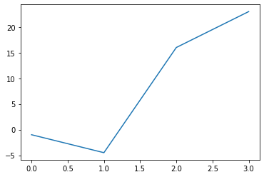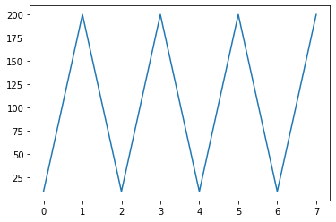

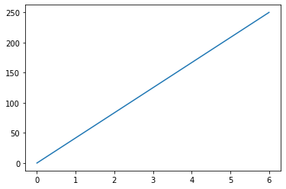

Algorithm
Step 1: Start the program
Step 2: Import misc module from scipy, pyplotmodule from matplotlib and numpy module
Step 3: Using misc method face, store the raccoon image into panda object
Step 4: Display the raccoon image
Step 5: Stop the program

Program
from scipy import misc from
matplotlib import pyplot as plt panda = misc.face() #plot or show image of face plt.imshow( panda )
plt.show()

Output
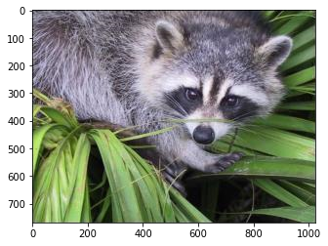

Particulars | Marks Allotted | Marks Obtained
Performance | 50
Viva-voce | 10
Record | 15
Total | 75

Result
Thus the program using matplotlib has been executed and verified successfully.

- Implementing real-time/technical applications using File handling.
(copy from one file to another, word count, longest word)

Date: 9.A. Copy from one file to another

Aim

To write a python program to copy from one file to another using file handling.

Algorithm
Step 1: Start the program
Step 2:Import the copyfile module from shutil
Step 3: Enter the source and destination file names
Step 4: Copy the contents of the source file to destination file using copyfile module Step 5: Stop the program

Program

from shutil import copyfile sourcefile = input("Enter source file name: ")
destinationfile = input("Enter destination file name: ") copyfile(sourcefile, destinationfile) print("File copied successfully!") c = open(destinationfile, "r")
print(c.read()) c.close()

Output
Source File Name: mega.txt
Hello India

Enter source file name: mega.txt Enter destination file name: varnika.txt File copied successfully!
Hello India

Particulars | Marks Allotted | Marks Obtained
Performance | 50
Viva-voce | 10
Record | 15
Total | 75

Result
Thus the file copying program has been executed and verified successfully.

Date: 9.B. Word count
Aim
To write a python program to find the count of word using file handling.

Algorithm
Step 1: Start the program
Step 2: Open the file mega.txt in read mode
Step 3: Read the content of the file
Step 4: Split the word using split method
Step 5: Count the words and display the count
Step 6: Stop the program

Program file=open("mega.txt","r")
data=file.read() words=data.split()
print("Number of words in text file:",len(words))

Output
Source File Name: mega.txt
Hello India

Number of words in text file: 2

Particulars | Marks Allotted | Marks Obtained
Performance | 50
Viva-voce | 10
Record | 15
Total | 75

Result
Thus the word count program has been executed and verified successfully.
Date: 9.C. Longest word
Aim
To write a python program to find the longest word.

Algorithm
Step 1: Start the program
Step 2: Read the file from which the longest word is to be found
Step 3: Compare all the words in the file and find the maximum length
Step 4: Display the longest word
Step 5: Stop the program

Program
def longest_word(filename): with open(filename,"r")as infile:
words=infile.read().split() max_len=len(max(words,key=len))
return [word for word in words if len(word)==max_len] file_name=input("Enter
the file name:")
print(longest_word(file_name))

Output
Source File Name: mega.txt
Welcome to India

Enter the file name:mega.txt
['Welcome']

Particulars | Marks Allotted | Marks Obtained
Performance | 50
Viva-voce | 10
Record | 15
Total | 75

Result
Thus the longest word program has been executed and verified successfully.

10. Implementing real-time/technical applications using Exception handling

(divide by zero error, voter’s age validity, student mark range validation)

Date: 10.A. Divide by zero error

Aim
To write a python program to find the divide by zero error using exception handling.

Algorithm
Step 1: Start the program
Step 2: Read two numbers a and b
Step 3: Perform a/b operation
Step 4: If b value is 0 then throw divide by zero exception
Step 5: If no exception then displays the result
Step 6: Stop the program

Program
a=int(input("Enter the value of a:"))
b=int(input("Enter the value of b:")) try: c=a/b print("Divide a / b:",c) except ZeroDivisionError: print("Found
Divide by Zero Error!")

Output
Enter the value of a:50 Enter the value of b:0
Found Divide by Zero Error!

Particulars | Marks Allotted | Marks Obtained
Performance | 50
Viva-voce | 10
Record | 15
Total | 75

Result
Thus the program for divide by zero error has been executed and verified successfully.
Date: 10.B. Voter’s age validity

Aim
To write a python program to validate the voters age using exception handling.

Algorithm
Step 1: Start the program
Step 2: Read the age value
Step 3: If age is greater than 18 then display “Eligible to Vote”
Step 4: Else display “Not Eligible to Vote” and throw the ValueError exception Step 5: Stop the program

Program
try:
age=int(input("Enter your age:")) if age>18: print("Eligible to vote") else: print("Not eligible to vote") except ValueError as err:
print(err) finally: print("Thank you")

Output

Enter your age:21
Eligible to vote
Thank you

Enter your age:17
Not eligible to vote
Thank you

Enter your age:varnika
invalid literal for int() with base 10: 'varnika'
Thank you

Particulars | Marks Allotted | Marks Obtained
Performance | 50
Viva-voce | 10
Record | 15
Total | 75

Result
Thus the program for voters age validity has been executed and verified successfully.

Date: 10.C. Student mark range validation

Aim
To write a python program to validate the student mark range using exception handling.

Algorithm
Step 1: Start the program
Step 2: Read the marks for python subject
Step 3: If the mark is greater than 90 then display “Grade: O”
Step 4: Elseif the mark is greater than 80 and less than 90 then display “Grade: A+” Step 5: Elseif the mark is greater than 70 and less than 80 then display “Grade: A”
Step 6: Elseif the mark is greater than 60 and less than 70 then display “Grade: B+”
Step 7: Elseif the mark is greater than 50 and less than 60 then display “Grade: B” Step 8: Else display “Grade: U”
Step 9: Otherwise throw the exception and display “Entered data is wrong, Try Again”
Step 10: Display “Thank you” Step 11: Stop the program

Program try:
python=int(input("Enter marks of the Python subject: "))
print("Python Subject Grade",end=" ") if(python>=90):
print("Grade: O") elif(python>=80 and python<90):
print("Grade: A+")
elif(python>=70 and python<80): print("Grade: A") elif(python>=60 and python<70):
print("Grade: B+") elif(python>=50 and python<60): print("Grade: B")
else:
print("Grade: U") except:
print("Entered data is wrong, Try Again") finally:
print("Thank you")

Output
Enter marks of the Python subject: 95
Python Subject Grade Grade: O
Thank you

Enter marks of the Python subject: a
Entered data is wrong, Try Again
Thank you

Particulars | Marks Allotted | Marks Obtained
Performance | 50
Viva-voce | 10
Record | 15
Total | 75

Result
Thus the student mark range validation program has been executed and verified successfully.

11. Exploring pygame tool

Date: 11. Exploring pygame tool

Aim
To understand about the use of pygame and steps to install pygame in Windows.

Algorithm
Step 1: Installing through pip: The good way to install Pygame is with the pip tool (which is what python uses to install packages). The command is the following:
py -m pip install -U pygame --user
Step 2: Installing through an IDE: The second way is to install it through an IDE and here we are using Pycharm IDE. Installation of pygame in the pycharm is straightforward. We can install it by running the above command in the terminal or use the following steps: _{o} Open the File tab and click on the Settings option.
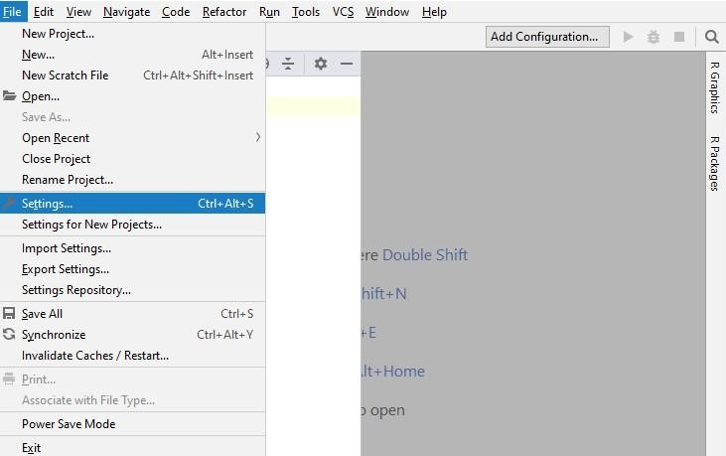
o Select the Project Interpreter and click on the + icon.
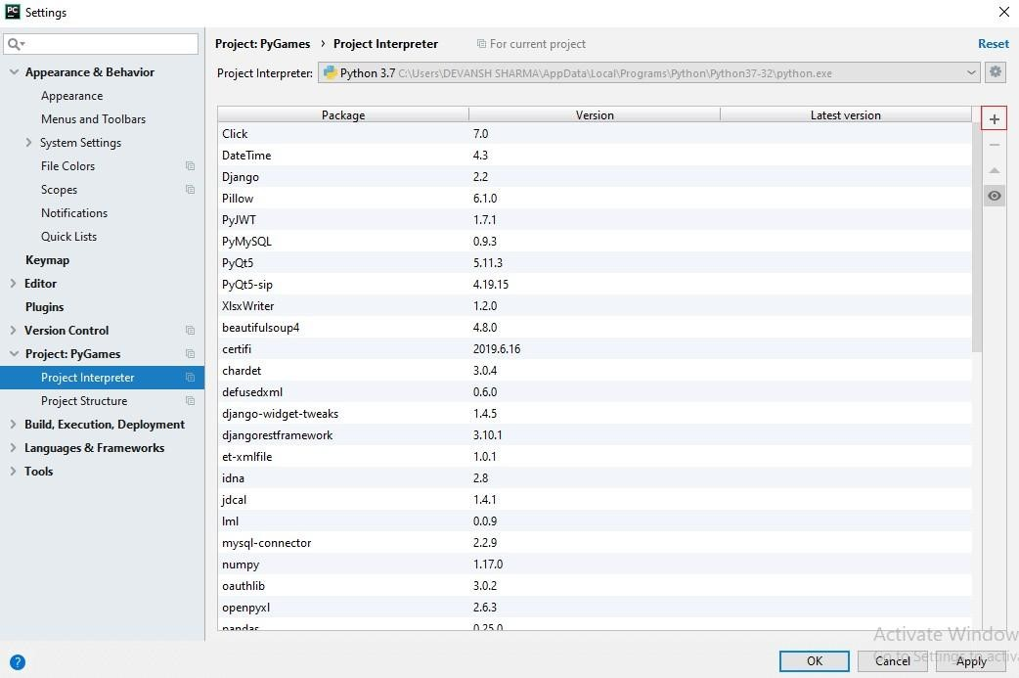 o It will display the search box. Search the pygame and click on the install package button.
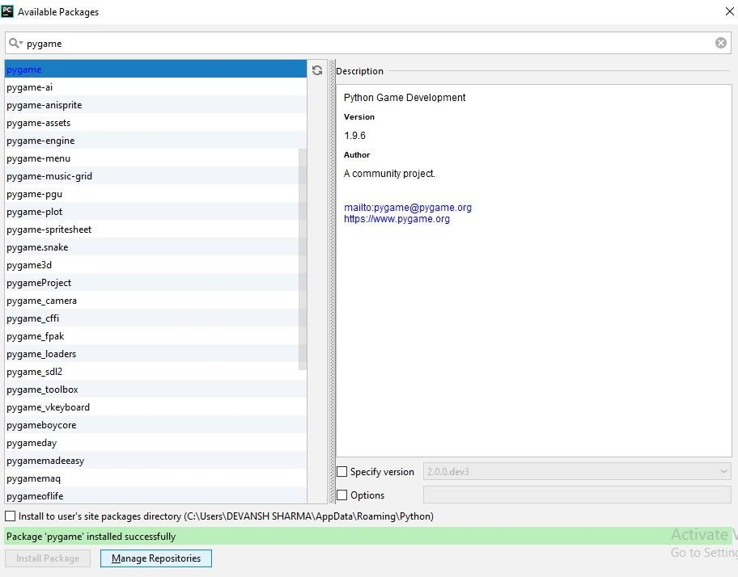

To check whether the pygame is properly installed or not, in the IDLE interpreter, type the following command and press Enter:
Step 3: import pygame
If the command runs successfully without throwing any errors, it means we have successfully installed Pygame and found the correct version of IDLE to use for pygame programming.
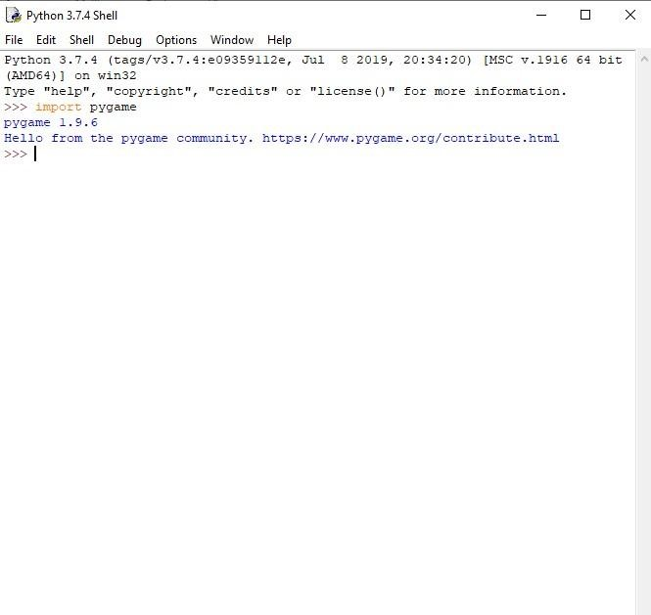

import pygame - This provides access to the pygame framework and imports all functions of pygame. pygame.init() - This is used to initialize all the required module of the pygame.
pygame.display.set_mode((width, height)) - This is used to display a window of the desired size. The return value is a Surface object which is the object where we will perform graphical operations.
pygame.event.get()- This is used to empty the event queue. If we do not call this, the window messages
will start to pile up and, the game will become unresponsive in the opinion of the operating system.
pygame.QUIT - This is used to terminate the event when we click on the close button at the corner of the window.
pygame.display.flip() - Pygame is double-buffered, so this shifts the buffers. It is essential to call this function in order to make any updates that you make on the game screen to make visible.
pygame.QUIT - This is used to terminate the event when we click on the close button at the corner of the window.
pygame.display.flip() - Pygame is double-buffered, so this shifts the buffers. It is essential to call this function in order to make any updates that you make on the game screen to make visible.

Step 4: Pygame Surface
The pygame Surface is used to display any image. The Surface has a pre-defined resolution and pixel format. The Surface color is by default black. Its size is defined by passing the size argument.
Surfaces can have the number of extra attributes like alpha planes, color keys, source rectangle clipping, etc. The blit routines will attempt to use hardware acceleration when possible; otherwise, they will use highly enhanced software blitting methods.
Step 5: Pygame Clock
Times are represented in millisecond (1/1000 seconds) in pygame. Pygame clock is used to track the time. The time is essential to create motion, play a sound, or, react to any event. In general, we don't count time in seconds. We count it in milliseconds. The clock also provides various functions to help in controlling the game's frame rate. The few functions are the following:
tick()
This function is used to update the clock. The syntax is the following:
tick(framerate=0)
This method should be called once per frame. It will calculate how many milliseconds have passed since the previous call. The framerate argument is optional to pass in the function, and if it is passed as an argument then the function will delay to keep the game running slower than the given ticks per second. tick_busy_loop()
The tick_busy_loop() is same as the tick(). By calling the Clock.tick_busy_loop(20) once per frame, the program will never run at more than 20 frames per second. The syntax is the following:
tick_busy_loop() get_time()
The get_time() is used to get the previous tick. The number of a millisecond that isdra passed between the last two calls in Clock.tick().
get_time()
Step 6: Pygame Blit
The pygame blit is the process to render the game object onto the surface, and this process is called blitting. When we create the game object, we need to render it. If we don't render the game objects and run the program, then it will give the black window as an output.
Blitting is one of the slowest operations in any game so, we need to be careful to not to blit much onto the screen in every frame. The primary function used in blitting is blit(), which is:
blit() blit(source,dest,area=None,special_flags=0)
This function is used to draw one image into another. The draw can be placed with the dest argument.
The dest argument can either be a pair of coordinates representing the upper left corner of the source.
Step 7: Pygame Adding Image
To add an image on the window, first, we need to instantiate a blank surface by calling the Surface constructor with a width and height tuple. surface = pygame.Surface((100,100))
The above line creates a blank 24-bit RGB image that's 100*100 pixels with the default black color.
For the transparent initialization of Surface, pass the SRCALPHA argument.
surface = pygame.Surface((100,100), pygame.SRCALPHA)

Step 8: Pygame Rect
Rect is used to draw a rectangle in Pygame. Pygame uses Rect objects to store and manipulate rectangular areas. A Rect can be formed from a combination of left, top, width, and height values. It can also be created from Python objects that are already a Rect or have an attribute named "rect".
The rect() function is used to perform changes in the position or size of a rectangle. It returns the new copy of the Rect with the affected changes. No modification happens in the original rectangle.
The Rect object has various virtual attributes which can be used to move and align the Rect:
1.x,y
2.top, left, right, bottom
3.topleft, bottomleft, topright, bottomright
4.midtop, midleft, midbottom, midright
5.center, centerx, centery
6.size, width, height
7.w,h
The dimension of the rectangle can be changed by assigning the size, width, or height. All other assignment moves the rectangle without resizing it.
If the width or height is a non-zero value of Rect, then it will return True for a non-zero test. Some methods return a Rect with 0 sizes to represent an invalid rectangle.
Step 9: Pygame Keydown
Pygame KEYDOWN and KEYUP detect the event if a key is physically pressed and released. KEYDOWN detects the key press and, KEYUP detects the key release. Both events (Key press and Key release) have two attributes which are the following:
- key: Key is an integer id which represents every key on the keyword.
- mod: This is a bitmask of all the modifier keys that were in the pressed state when the event occurred.
Step 10: Pygame Draw
Pygame provides geometry functions to draw simple shapes to the surface. These functions will work for rendering to any format to surfaces. Most of the functions accept a width argument to signify the size of the thickness around the edge of the shape. If the width is passed 0, then the shape will be solid(filled).
All the drawing function takes the color argument that can be one of the following formats:
- A pygame.Color objects _{o} An (RGB) triplet(tuple/list) _{o} An (RGBA) quadruplet(tuple/list) _{o}
An integer value that has been mapped to the surface's pixel format

Particulars | Marks Allotted | Marks Obtained
Performance | 50
Viva-voce | 10
Record | 15
Total | 75

Result
Thus the pygame software has been installed and verified successfully.

12. Developing a game activity using Pygame like bouncing ball, car race etc.

Date: 12.A.Bouncing Ball

Aim
To write a python program for bouncing ball using pygame.

Algorithm
Step 1: Start the program
Step 2: Import the modules sys,Pygame
Step 3: pygame.init()is used to initialize all the pygame modules
Step 4: Initialize the size as width and height
Step 5: Assign the speed list values 1,1
Step 6: Initialize the background values
Step 7: Form a screen by using pygame. display. set_mode() method.
Step 8: Display the screen title as "Bouncing ball"
Step 9: Load the ball image into ball object
Step 10: get_rect() returns a new rectangle covering the entire surface
Step 11: Do the following steps
Step 12: Event loop is used to get the events from the event queue
Step 13: If event type is pygame.QUIT then exit from the runtime environment
Step 14: move() method recursively moves a file to another location
Step 15: If the object surface reaches left or right of the screen then assign speed[0] = -speed[0]
Step 16: If the object surface reaches top or bottom of the screen then assign speed[1] = -speed[0]
Step 17: fill()method is used to fill the display with the color specified
Step 18: blit() method copies the contents of onesurface onto another surface
Step 19: pygame.display.flip() method updates the entire surface Step 20: Stop the program

Program

import sys, Pygame pygame.init() size = width, height = 800, 400 speed = [1, 1]
background = 255, 255, 255 screen = pygame.display.set_mode(size) pygame.display.set_caption("Bouncing ball") ball = pygame.image.load("ball.png")
ballrect = ball.get_rect() while 1: for event in pygame.event.get(): if event.type == pygame.QUIT: sys.exit()
ballrect = ballrect.move(speed) if ballrect.left< 0 or ballrect.right> width: speed[0] = -speed[0] if ballrect.top< 0
or ballrect.bottom> height: speed[1] = speed[1] screen.fill(background) screen.blit(ball, ballrect)
pygame.display.flip()

Output

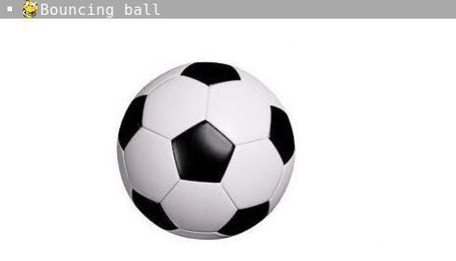

Particulars | Marks Allotted | Marks Obtained
Performance | 50
Viva-voce | 10
Record | 15
Total | 75
Result
Thus the pygame program has been executed and verified successfully.

Date: 12.B. Car Race

Aim
To write a python program for car race using pygame.

Algorithm
Step 1: Start the program
Step 2: Import the Pygame package
Step 3: pygame.init() is used to initialize all the pygame modules
Step 4: Import all modules in locals’ pygame
Step 5:Import the random package
Step 6: Form a screen by using pygame. display. set_mode() method.
Step 7: Display the screen title as Racing Beast
Step 8: Display the logo as car image
Step 9: Display the background image
Step 10: Setting our player in coordinates
Step 11: Load another 3 different cars for car racing
Step 12: Get the events like LEFT, RIGHT to move the car
Step 13: Setting boundary for our main car
Step 14: Change the screen colour
Step 15: Displaying the background image
Step 16: Displaying the loaded cars
Step 17: Updating the values
Step 18: Movement of the enemies infinitely
Step 19: Loop will continue until the original car getting crashed Step
20: Stop the program

Program import pygame
pygame.init() #initializes the Pygame
from pygame.locals import* #import all modules from Pygame import
random
screen = pygame.display.set_mode((798,600))

#changing title of the game window pygame.display.set_caption('Racing Beast') #changing the logo logo = pygame.image.load('car game/logo.jpeg') pygame.display.set_icon(logo)

#defining our gameloop function

def gameloop(): #setting background image bg = pygame.image.load('car game/bg.png')

# setting our player maincar = pygame.image.load('car game\car.png') maincarX = 350 maincarY = 495 maincarX_change = 0 maincarY_change = 0

#other cars car1 = pygame.image.load('car game\car1.jpeg') car1X = random.randint(178,490) car1Y = 100

car2 = pygame.image.load('car game\car2.png') car2X = random.randint(178,490) car2Y = 100

car3 = pygame.image.load('car game\car3.png') car3X = random.randint(178,490) car3Y = 100

run = True while run: for event in pygame.event.get(): if event.type == pygame.QUIT:
run = False

#checking if any key has been pressed if event.type == pygame.KEYDOWN: if event.key == pygame.K_RIGHT: maincarX_change += 5

if event.key == pygame.K_LEFT:
maincarX_change -= 5

if event.key == pygame.K_UP: maincarY_change -= 5

if event.key == pygame.K_DOWN:
maincarY_change += 5

#checking if key has been lifted up if event.type == pygame.KEYUP:
if event.key == pygame.K_RIGHT:
maincarX_change = 0

if event.key == pygame.K_LEFT: maincarX_change = 0

if event.key == pygame.K_UP:
maincarY_change = 0

if event.key == pygame.K_DOWN:
maincarY_change = 0

#setting boundary for our main car if maincarX < 178: maincarX = 178 if maincarX > 490:
maincarX = 490

if maincarY < 0:
maincarY = 0 if maincarY > 495:
maincarY = 495

#CHANGING COLOR WITH RGB VALUE, RGB = RED, GREEN, BLUE screen.fill((0,0,0))

#displaying the background image screen.blit(bg,(0,0))

#displaying our main car screen.blit(maincar,(maincarX,maincarY))

#displaing other cars screen.blit(car1,(car1X,car1Y)) screen.blit(car2,(car2X,car2Y)) screen.blit(car3,(car3X,car3Y))

#updating the values
maincarX += maincarX_change maincarY +=maincarY_change #movement of the enemies car1Y += 10 car2Y += 10 car3Y
+= 10

#moving enemies infinitely if car1Y > 670: car1Y = -100 if car2Y > 670: car2Y = -150 if car3Y >
670: car3Y = -200 pygame.display.update()

gameloop()

Output

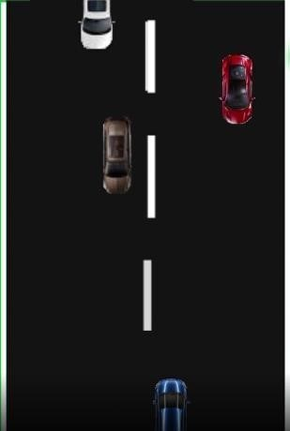

Particulars | Marks Allotted | Marks Obtained
Performance | 50
Viva-voce | 10
Record | 15
Total | 75

Result
Thus the pygame program has been executed and verified successfully.

